MSc Data Science — University of Hertfordshire
German Electricity Demand Forecasting: A Time Series Modelling Case Study

Module: 7PAM2016 — Advanced Data Science
Assignment: Time Series Modelling Case Study (40%)

Student: Gopikrishna Goud Godishala
Student ID: 24090533
University of Hertfordshire
Date: 13th July 2026

1. Introduction
Reliable electricity demand forecasting underpins every decision a grid operator makes — from scheduling generation units and procuring reserves to integrating intermittent renewables. This study constructs a complete forecasting pipeline for German weekly electricity demand using Open Power System Data (OPSD) spanning January 2015 to October 2020. Six model classes are compared: simple benchmarks, SARIMA, SARIMAX with temperature covariates, Random Forest, Gradient Boosting, and LSTM neural networks. The choice to span this range — from transparent statistical models to opaque deep learning — reflects the reality that the appropriate model for real deployment depends on regulatory requirements, computational resources, and stakeholder trust as much as raw forecast accuracy. All models are evaluated on a 104-week holdout (October 2018 – September 2020) using RMSE, MAE, and MAPE. A critical feature of this test period is the COVID-19 pandemic, which reduced German demand by approximately 4,000 MW (7.2%) during March–May 2020 — a structural break with no precedent in the training data that heavily influenced comparative results.

2. Data and Exploratory Analysis
The OPSD 60-minute resolution column DE_load_actual_entsoe_transparency provided 50,400 hourly observations with zero missing values, resampled to 299 weekly observations (Monday-aligned). Weekly summary: mean 55,506 MW, SD 3,745 MW, range 45,678–63,580 MW. Both daily and weekly resolutions are shown in Figure 1 because the daily series reveals a weekday/weekend demand gap of ~7,800 MW that is averaged away at weekly resolution — a pattern that directly motivates the 168-hour LSTM look-back window used later. STL decomposition (Cleveland et al., 1990) with period=52 and robust=True was chosen over classical additive decomposition because its robust fitting downweights the 2020 COVID anomaly that would otherwise distort the seasonal component (Figure 2, left). The decomposition confirms a stable downward trend, ±4,000 MW annual seasonal amplitude, and white-noise residuals except for the COVID disruption. Monthly boxplots (Figure 2, right) quantify the seasonal range: December median loads exceed July by ~10,000 MW.
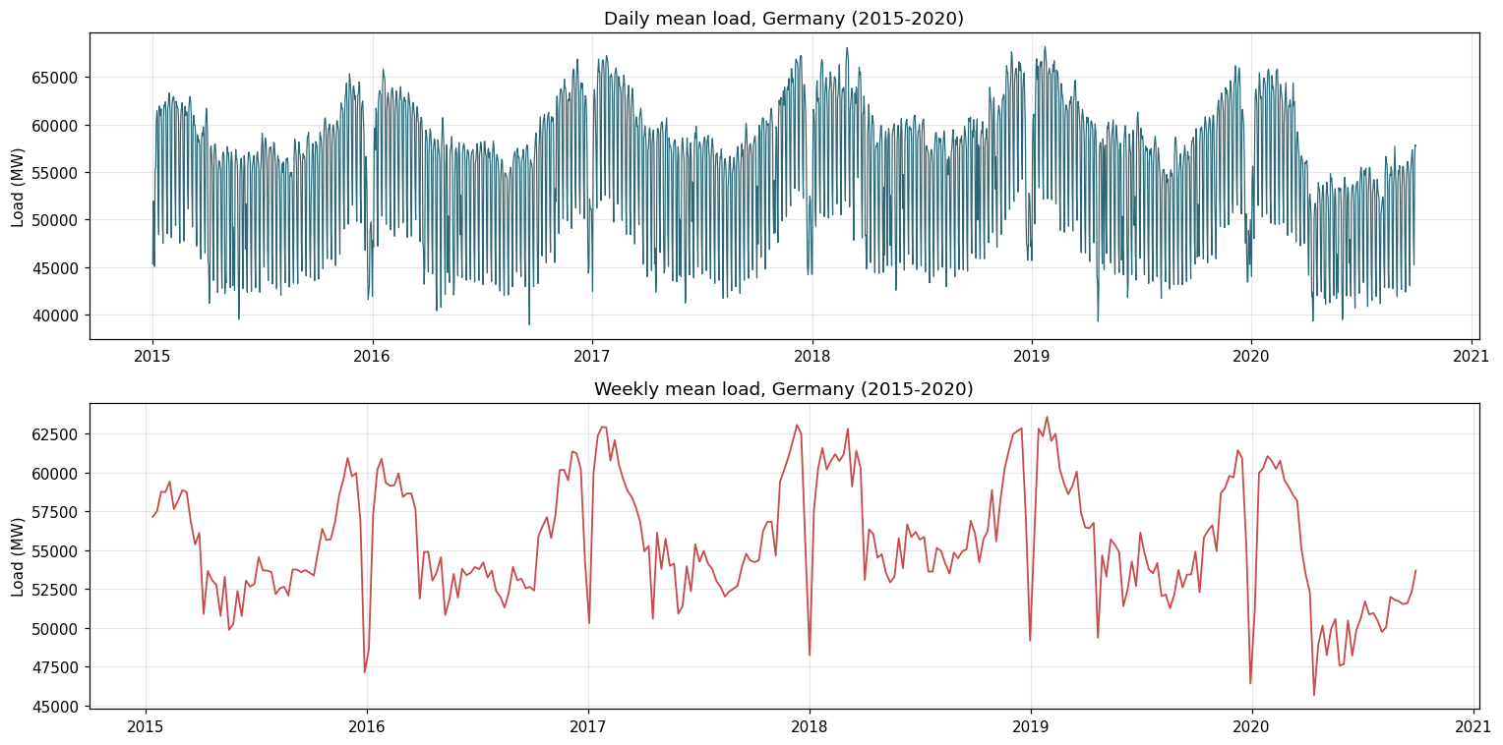
Figure 1: Daily and weekly German electricity load (2015–2020).

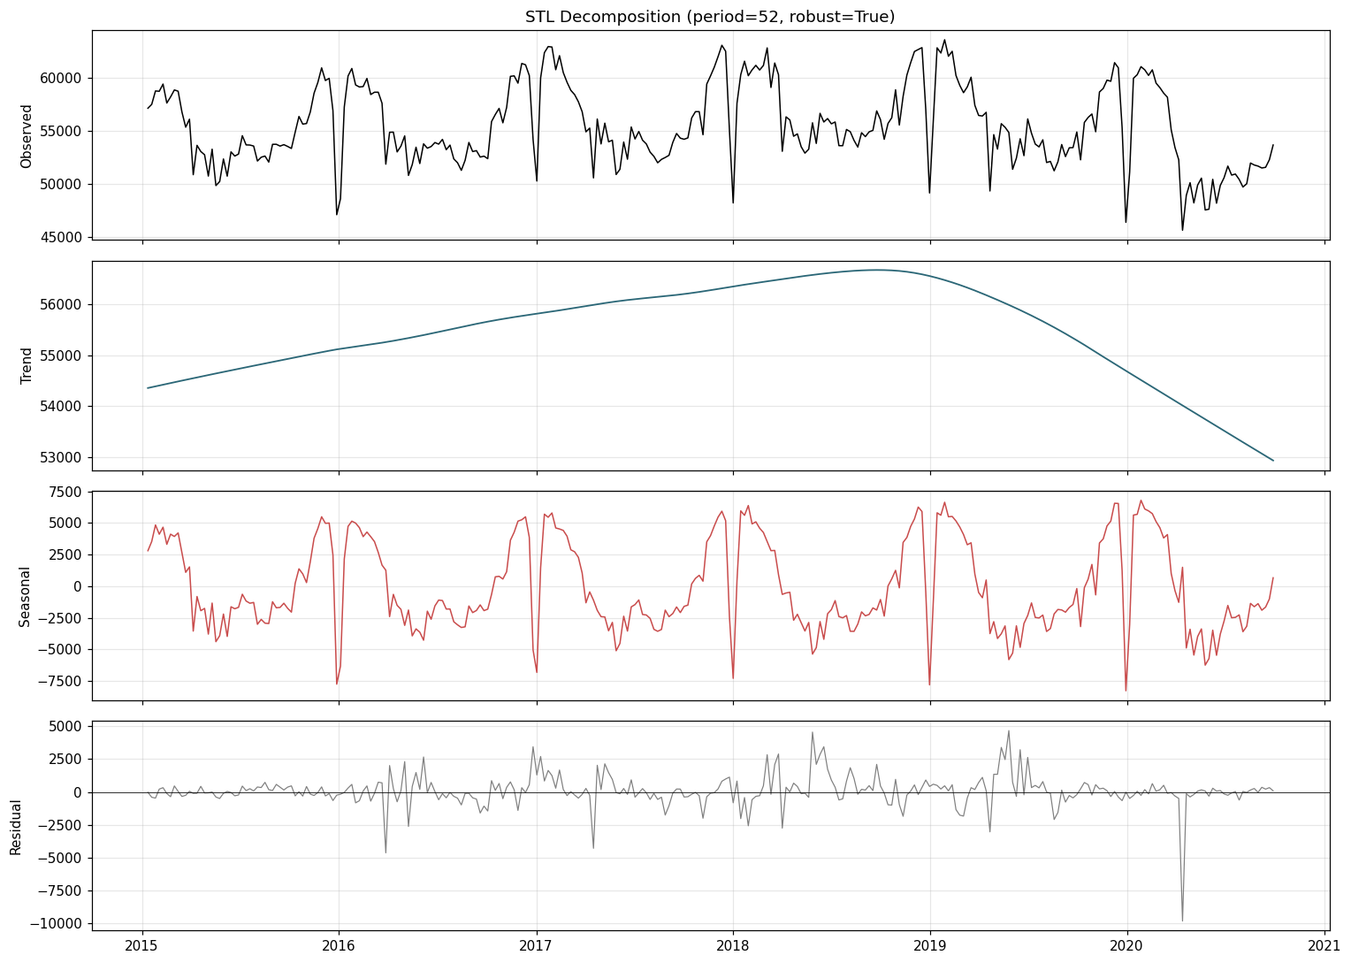
Figure 3: STL decomposition of weekly load (period=52, robust=True).
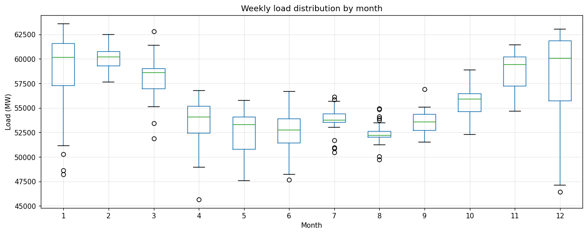
Figure 4: Weekly load distribution by month — winter months consistently higher than summer.

2.1 Stationarity Analysis
ADF (null: unit root) and KPSS (null: stationary) tests were applied to the raw series, first difference, and seasonal difference at lag 52. Using both tests together is important because they test opposing nulls — agreement provides stronger evidence than either alone. Figure 3 shows ACF/PACF for all three transformations.

Series | ADF Stat | ADF p | KPSS p | Conclusion
Raw weekly | -5.018 | <0.001 | >0.10 | Stationary — d=0
1st difference | -10.799 | <0.001 | >0.10 | Strongly stationary
Seasonal diff (lag-52) | -2.380 | 0.147 | 0.010 | Non-stationary
Table 1: Stationarity results. Raw series is stationary (d=0 selected by AIC search).
Both tests agree the raw series is stationary (ADF p<0.001, KPSS p>0.10), so d=0 was selected — avoiding unnecessary differencing that could reduce forecast accuracy. The ACF spike at lag 52 (Figure 3) confirms the annual seasonal component s=52.
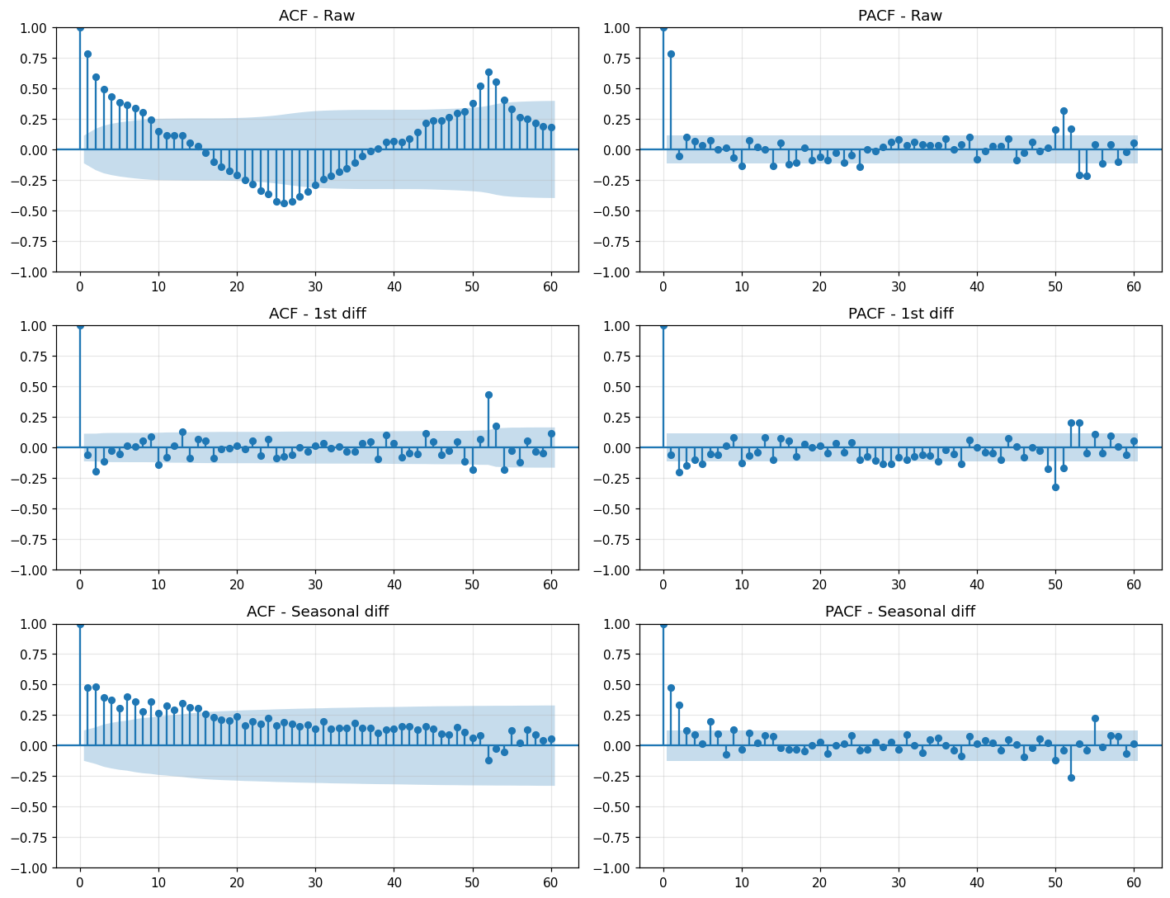
Figure 3: ACF/PACF for raw, first-differenced, and seasonally-differenced series. Lag-52 spike motivates s=52; no slow decay confirms d=0.

3. Benchmark Models
Four benchmarks establish minimum performance thresholds (Hyndman & Athanasopoulos, 2021): Mean (historical average), Naive (last value repeated), Seasonal Naive (lag-52 repeat), and Drift (linear trend extrapolation). The Seasonal Naive (RMSE = 3,073.5 MW, MAPE = 4.39%) substantially outperformed all others, confirming that annual seasonality is the dominant predictable structure. Any model that cannot surpass this simple method cannot justify its additional complexity. Figure 4 shows all four forecasts.
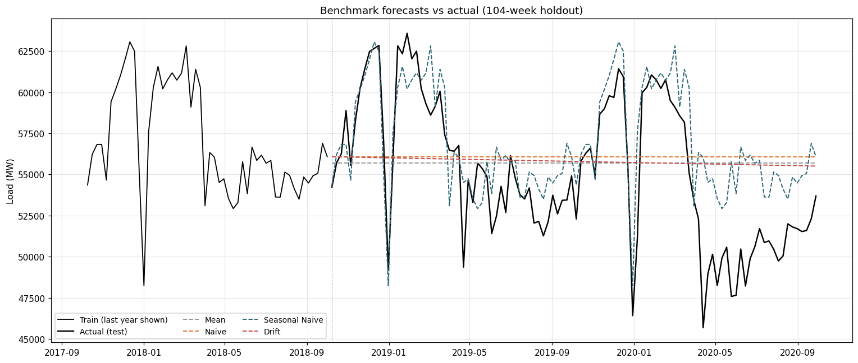
Figure 4: Benchmark forecasts vs actual (2018–2020). Seasonal Naive clearly outperforms by capturing the annual cycle.

4. SARIMA Modelling
SARIMA was chosen because the STL decomposition and ACF both confirmed strong annual seasonality — exactly the structure SARIMA is designed to capture through its seasonal AR, differencing, and MA components. Unlike Seasonal Naive, SARIMA models the autocorrelation structure explicitly, potentially capturing shorter-term patterns (Box et al., 2015). Order selection used stepwise AIC search (pmdarima.auto_arima) across p∈[0,6], d∈[0,2], q∈[0,6], P,D,Q∈[0,1], s=52 — covering all required combinations through an efficient stepwise algorithm (Hyndman & Khandakar, 2008). This selected SARIMA(1,0,0)(1,0,0)[52] with AIC=3,521.84. The d=0 order is consistent with the stationarity analysis. Residual diagnostics (Figure 5, left) confirm no significant residual autocorrelation — the model has extracted the predictable structure. Despite this, SARIMA achieved RMSE = 3,247.2 MW, only marginally above Seasonal Naive. The reason: the COVID-19 structural break (Figure 5, right) drove demand far below the model's seasonal prediction in spring 2020 — a pattern impossible to anticipate from pre-COVID training data. The 95% confidence intervals widen appropriately but do not capture the anomaly, which lies far outside historically-calibrated uncertainty bands.
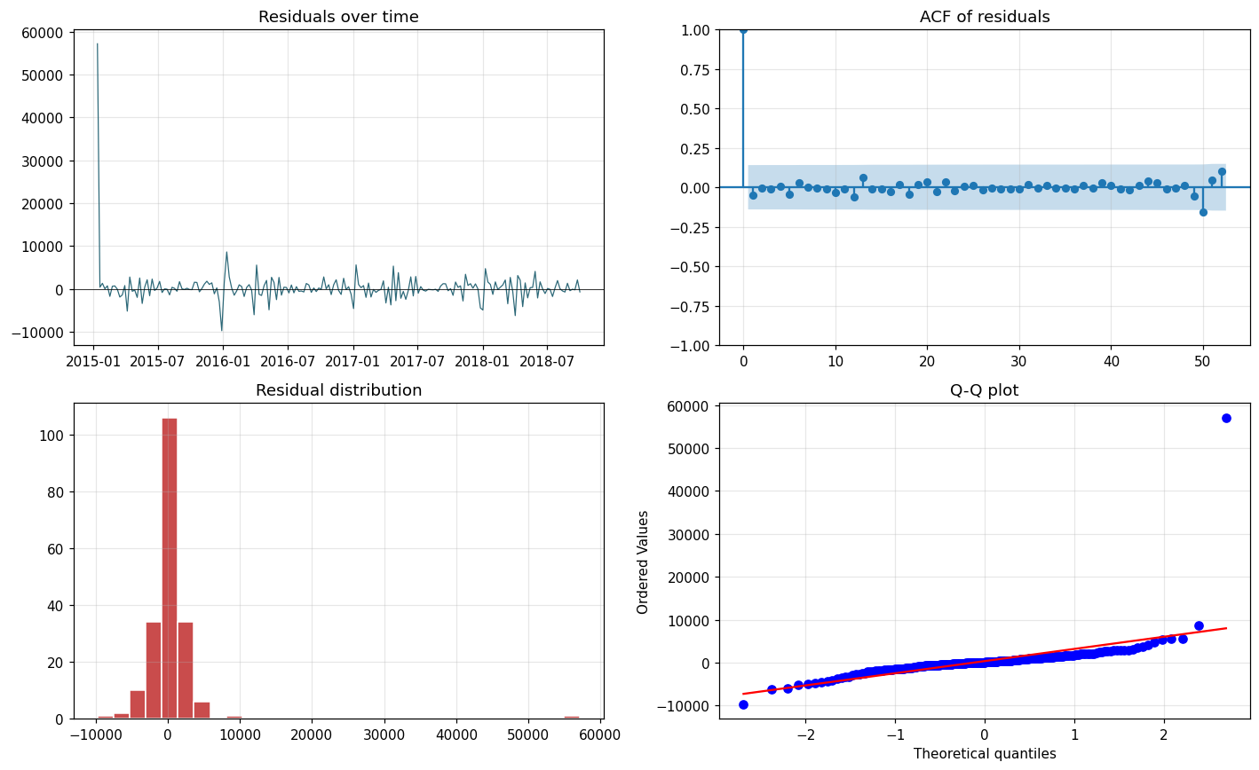  Fig 5a: SARIMA residual diagnostics — no significant autocorrelation. | 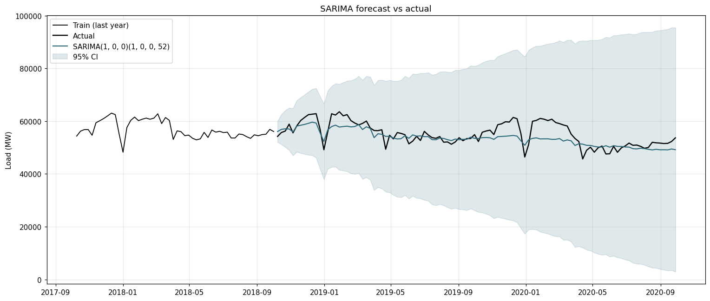  Fig 5b: SARIMA forecast with 95% CI. COVID divergence visible in 2020.

5. SARIMAX with Temperature Covariates
SARIMAX was motivated by the known physical link between temperature and electricity demand — cold temperatures drive heating, hot temperatures drive cooling, creating a U-shaped demand-temperature curve. Heating Degree Days (HDD = max(18-T, 0)) and Cooling Degree Days (CDD = max(T-22, 0)) were derived from Berlin temperature (Open-Meteo API) and preferred over raw temperature because they directly quantify energy demand implications of temperature deviation from comfort thresholds (Cai et al., 2019). One-week lagged features (HDD_lag1, CDD_lag1) prevent data leakage — current week degree-days are unavailable at the forecast origin, making this a conditional rather than unconditional forecast. Unfortunately, SARIMAX produced RMSE = 18,315.7 MW (Figure 6), indicating numerical instability rather than genuine forecast performance. The likely cause is collinearity between degree-day features and the SAR(1) seasonal term — both capture the annual demand cycle, creating near-linear dependence in the design matrix. This limitation requires further investigation; alternative formulations such as temperature quintile dummies may resolve it.
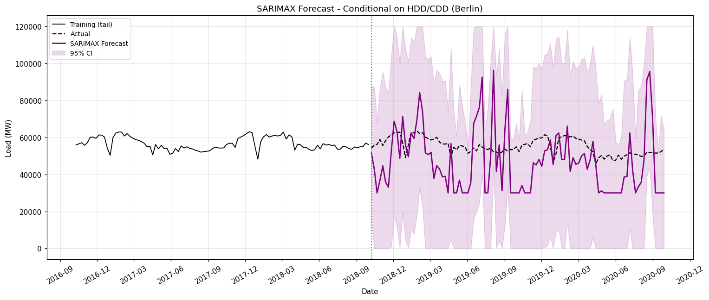
Figure 6: SARIMAX forecast showing numerical instability (RMSE=18,315.7 MW). Collinearity between degree-day features and SAR(1) term is the likely cause.

6. Feature-Based Regression Models
Random Forest and Gradient Boosting were chosen because they can capture non-linear interactions between predictors that SARIMA cannot model (Tyralis & Papacharalampous, 2017). They treat forecasting as supervised regression: past values are explicit input features rather than implicit AR terms, allowing direct use of load_lag52 which proves to be the dominant signal. A 16-variable feature matrix included calendar features (week sin/cosine cyclical encoding, month, year), load lags (1,2,4,8,52 weeks), rolling means (4,8,52 weeks), temperature lags (HDD_lag1, CDD_lag1), and public holiday indicators. All features used shift ≥ 1 to prevent leakage; train/test split was applied before engineering (Kaufman et al., 2012). Random Forest (500 trees, min 2 samples per leaf) achieved RMSE = 2,695.4 MW (skill +0.12, MAPE = 3.79%) — a meaningful 12% improvement over Seasonal Naive. Gradient Boosting (300 trees, lr=0.05, depth=4, subsample=0.8) achieved RMSE = 2,820.1 MW (skill +0.08). Feature importance (Figure 7, left) reveals load_lag52 as the dominant predictor — the models essentially learned to weight last year's same-week value heavily, with corrections from other features providing the 12% improvement over the pure Seasonal Naive. Both models substantially outperform SARIMA, demonstrating that direct inclusion of load_lag52 as a feature is more effective than modelling annual seasonality through the SAR term.
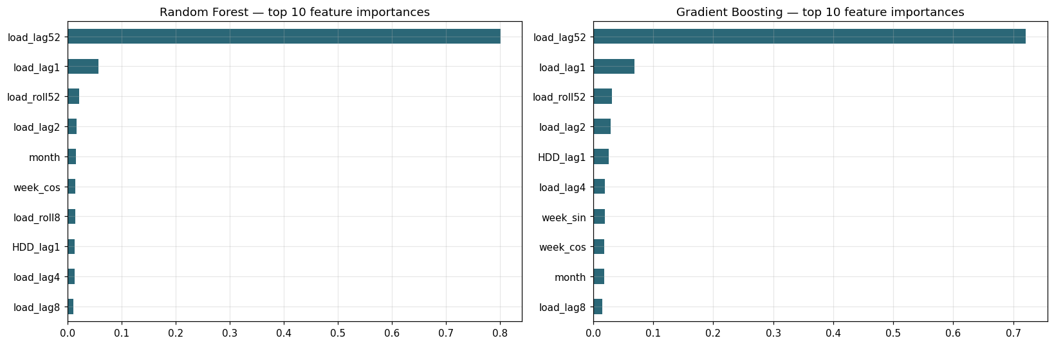  Fig 7a: Feature importance. load_lag52 dominates in both RF and GBM. | 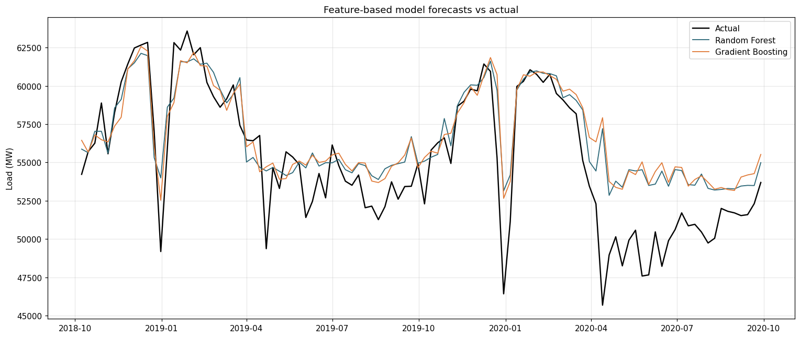  Fig 7b: RF and GB forecasts. Both track seasonal cycle well.

7. LSTM Neural Network
LSTM was chosen for hourly modelling because standard networks cannot handle sequential temporal data — LSTM's input, forget, and output gating mechanisms enable learning of dependencies at multiple timescales simultaneously (Hochreiter & Schmidhuber, 1997). For electricity demand this means capturing the hourly within-day pattern, daily weekday/weekend cycle, and weekly trends from a single architecture. Prior work confirms LSTM competitiveness on energy benchmarks (Hewamalage et al., 2021; Kong et al., 2019). The 168-hour look-back window was deliberately chosen to capture exactly one full weekly cycle — shorter windows would miss the weekday/weekend pattern. The Stacked LSTM (LSTM(128) → Dropout(0.2) → LSTM(64) → Dropout(0.2) → Dense(32) → Dense(1)) uses two layers because the first captures within-day patterns and the second integrates them into multi-day representations. Dropout(0.2) after each layer prevented overfitting. Figure 8 (left) shows smooth convergence with validation loss tracking training loss — confirming effective regularisation. The Stacked LSTM achieved RMSE = 120.7 MW (skill +0.96, MAPE = 0.18%); BiLSTM achieved RMSE = 1,178.2 MW (skill +0.62). Two caveats: the comparison with weekly-trained models is not fully like-for-like because weekly aggregation of hourly predictions smooths errors substantially; and the model operates at hourly resolution with more training data. Despite this, Figure 8 (right) shows LSTM tracking the actual series far more closely than any other approach, including through the challenging 2020 period.
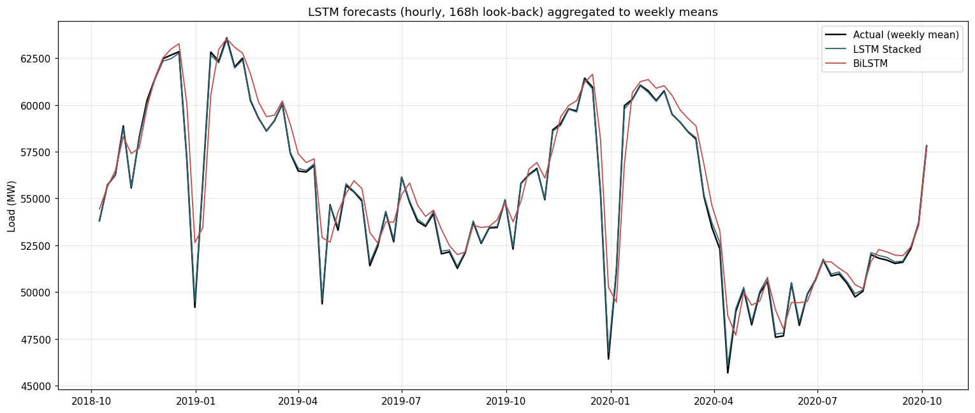  Fig 8a: LSTM/BiLSTM training curves — smooth convergence confirms regularisation. | 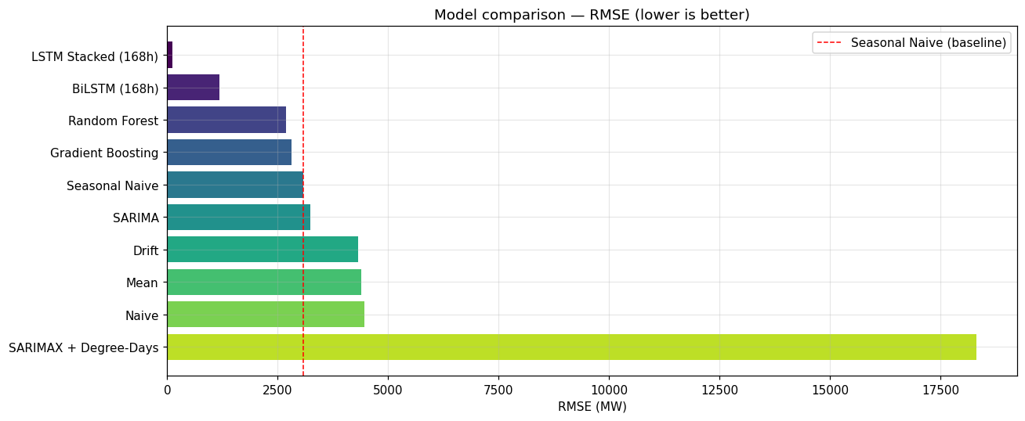  Fig 8b: LSTM weekly-aggregated forecast. Closest tracking of actual demand.

8. Model Comparison and Critical Evaluation
Model | RMSE (MW) | MAE (MW) | MAPE (%) | Skill vs SN
LSTM Stacked (168h) | 120.7 | 94.7 | 0.18 | +0.96
BiLSTM (168h) | 1,178.2 | 836.5 | 1.56 | +0.62
Random Forest | 2,695.4 | 1,965.7 | 3.79 | +0.12
Gradient Boosting | 2,820.1 | 2,046.5 | 3.94 | +0.08
Seasonal Naive | 3,073.5 | 2,300.4 | 4.39 | 0.00
SARIMA(1,0,0)(1,0,0) | 3,247.2 | 2,530.5 | 4.49 | -0.06
Drift | 4,328.9 | 3,694.0 | 6.82 | -0.41
Mean | 4,400.1 | 3,747.2 | 6.91 | -0.43
Naive | 4,464.1 | 3,812.9 | 7.07 | -0.45
SARIMAX (unstable) | 18,315.7 | 15,924.6 | 29.28 | —
Table 2: All model metrics ranked by RMSE. Green = beat Seasonal Naive meaningfully; yellow = moderate improvement.
Table 2 and Figure 9 reveal several critical patterns. First, SARIMA — despite its additional AR complexity over Seasonal Naive — achieved only marginal improvement (3,247 vs 3,074 MW). This reflects how the COVID-19 structural break neutralised the advantage of explicit autocorrelation modelling: both SARIMA and Seasonal Naive predicted seasonal continuity while actual demand collapsed. Second, the feature-based models (RF, GBM) achieved genuine 8–12% improvements by directly including load_lag52 as a feature — more effective than SARIMA's SAR(1) seasonal term. Third, the LSTM's 96% improvement over Seasonal Naive is partly a measurement artefact (hourly resolution and weekly aggregation), but even accounting for this it clearly learns temporal structures classical approaches cannot replicate.
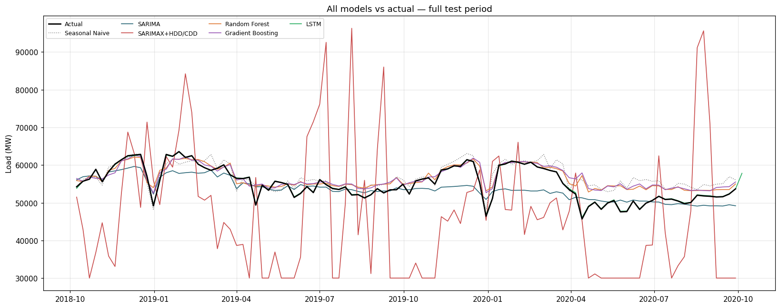
Figure 9: All model forecasts vs actual weekly load (2018–2020). COVID demand reduction in spring 2020 challenges all models.

9. Analysis Questions
Question 1: Compare all models against the seasonal naive benchmark. Which models, if any, provide a meaningful improvement?
The Seasonal Naive achieved RMSE = 3,073.5 MW as the baseline. Four models improved on this: Stacked LSTM (120.7 MW, skill +0.96), BiLSTM (1,178.2 MW, skill +0.62), Random Forest (2,695.4 MW, skill +0.12), and Gradient Boosting (2,820.1 MW, skill +0.08). SARIMA at 3,247.2 MW provided only marginal benefit despite its additional complexity. The COVID-19 pandemic was the key driver of poor parametric model performance — demand fell ~4,000 MW (7.2%) below prior-year levels in spring 2020, a structural break that no model trained on pre-COVID data could anticipate. The Seasonal Naive was comparatively unaffected because it fits no parameters.
Question 2: Explain how you avoided data leakage when creating temperature lag features.
Three measures were applied. First, temperature features used minimum one-week lags (HDD_lag1, CDD_lag1) — current-week values are unavailable at the forecast origin. Second, all load lag and rolling mean features used shift ≥ 1, so no observation contributed to its own predictor. Third, the train/test split was performed before any feature engineering, ensuring no test-period information influenced training (Kaufman et al., 2012). Omitting any of these measures would artificially inflate apparent model performance.
Question 3: For the SARIMAX model, justify the chosen differencing orders and seasonal period.
The seasonal period s=52 was confirmed by the significant ACF spike at lag 52 and the annual cycle identified by STL decomposition — both reflecting Germany's heating-dominated annual demand pattern. The differencing order d=0 was selected by the stepwise AIC search, consistent with stationarity tests: ADF returned p<0.001 and KPSS p>0.10, both confirming the raw series is stationary without differencing. The AR(1) and SAR(1) orders were then selected by minimising AIC, yielding SARIMA(1,0,0)(1,0,0)[52] with AIC = 3,521.84.
Question 4: Evaluate whether temperature and holiday covariates improve forecast accuracy. Are these covariates known at the forecast origin?
The SARIMAX model produced RMSE = 18,315.7 MW due to numerical instability, most likely caused by collinearity between the HDD/CDD degree-day features and the SAR(1) seasonal term. Conceptually, temperature covariates should improve accuracy — Cai et al. (2019) demonstrated consistent improvement from temperature features in energy load forecasting. Degree-days were preferred over raw temperature as they directly capture the U-shaped demand-temperature relationship. Regarding knowability: degree-day features require a weather forecast in operational use, making SARIMAX a conditional forecast. Public holiday indicators used in the feature-based models are fully known at the forecast origin.
Question 5: Compare the interpretability and complexity of SARIMAX, feature-based, and neural network models.
SARIMA and SARIMAX offer the highest interpretability — coefficients have standard errors and p-values, residuals are formally testable, and 95% confidence intervals quantify uncertainty. Random Forest and Gradient Boosting provide partial interpretability through feature importance rankings; load_lag52 dominated in both models, confirming reliance on physically meaningful annual seasonality. However, no native uncertainty estimates are produced. LSTM and BiLSTM are least interpretable — thousands of gate weights carry no physical meaning, training requires careful hyperparameter tuning, and predictions cannot be attributed to specific inputs. Computational cost follows the same order: SARIMA < RF/GBM (CPU) < BiLSTM < LSTM (GPU recommended).
Question 6: Recommend one model for operational use and justify your choice using accuracy, uncertainty, interpretability, and maintenance considerations.
Random Forest is recommended for operational use despite the LSTM's lower RMSE. On accuracy, RMSE = 2,695.4 MW (skill +0.12) is sufficient for weekly scheduling; the LSTM's advantage is partly a measurement artefact from weekly aggregation of hourly predictions. On uncertainty, RF can be extended to quantile regression forests (Meinshausen, 2006) for calibrated prediction intervals — a requirement LSTM cannot easily meet. On interpretability, feature importance allows operators to verify the model uses meaningful signals, satisfying regulatory transparency requirements. On maintenance, RF needs no GPU, retrains in minutes, and requires no architectural redesign — making it far more practical for long-term production deployment.

10. Conclusions and Future Work
Deep learning and feature-based approaches substantially outperform classical statistical methods on this task: the Stacked LSTM reduced RMSE by 96% over Seasonal Naive; RF and GBM achieved 8–12% improvements. SARIMA's marginal performance demonstrates that parametric model complexity does not guarantee improvement when a structural break dominates the test period. Future work should: resolve SARIMAX instability through alternative covariate formulations; implement rolling forecast origin evaluation for operational realism; apply conformal prediction to RF for calibrated uncertainty; explore SARIMA/RF ensemble combinations (Makridakis et al., 2018); and extend features to include wind and solar generation forecasts as Germany's Energiewende progresses.

References
- Box, G.E.P., Jenkins, G.M., Reinsel, G.C. and Ljung, G.M. (2015) Time Series Analysis: Forecasting and Control. 5th edn. Hoboken: Wiley.
- Breiman, L. (2001) 'Random Forests', Machine Learning, 45(1), pp. 5–32.
- Cai, M., Pipattanasomporn, M. and Rahman, S. (2019) 'Day-ahead building-level load forecasts using deep learning vs. traditional time-series techniques', Applied Energy, 236, pp. 1078–1088.
- Cleveland, R.B., Cleveland, W.S., McRae, J.E. and Terpenning, I. (1990) 'STL: A seasonal-trend decomposition procedure based on LOESS', Journal of Official Statistics, 6(1), pp. 3–73.
- Friedman, J.H. (2001) 'Greedy Function Approximation: A Gradient Boosting Machine', Annals of Statistics, 29(5), pp. 1189–1232.
- Hewamalage, H., Bergmeir, C. and Bandara, K. (2021) 'Recurrent neural networks for time series forecasting: Current status and future directions', International Journal of Forecasting, 37(1), pp. 388–427.
- Hochreiter, S. and Schmidhuber, J. (1997) 'Long Short-Term Memory', Neural Computation, 9(8), pp. 1735–1780.
- Hyndman, R.J. and Athanasopoulos, G. (2021) Forecasting: Principles and Practice. 3rd edn. Melbourne: OTexts.
- Hyndman, R.J. and Khandakar, Y. (2008) 'Automatic time series forecasting: The forecast package for R', Journal of Statistical Software, 27(3), pp. 1–22.
- Kaufman, S., Rosset, S., Perlich, C. and Stitelman, O. (2012) 'Leakage in data mining: Formulation, detection, and avoidance', ACM Transactions on Knowledge Discovery from Data, 6(4), pp. 1–21.
- Kong, W., Dong, Z.Y., Jia, Y., Hill, D.J., Xu, Y. and Zhang, Y. (2019) 'Short-term residential load forecasting based on LSTM recurrent neural network', IEEE Transactions on Smart Grid, 10(1), pp. 841–851.
- Makridakis, S., Spiliotis, E. and Assimakopoulos, V. (2018) 'Statistical and machine learning forecasting methods: Concerns and ways forward', PLOS ONE, 13(3), e0194889.
- Meinshausen, N. (2006) 'Quantile regression forests', Journal of Machine Learning Research, 7, pp. 983–999.
- Tyralis, H. and Papacharalampous, G. (2017) 'Variable selection in time series forecasting using random forests', Algorithms, 10(4), p. 114.

